1. Linked lists: Running of list_test

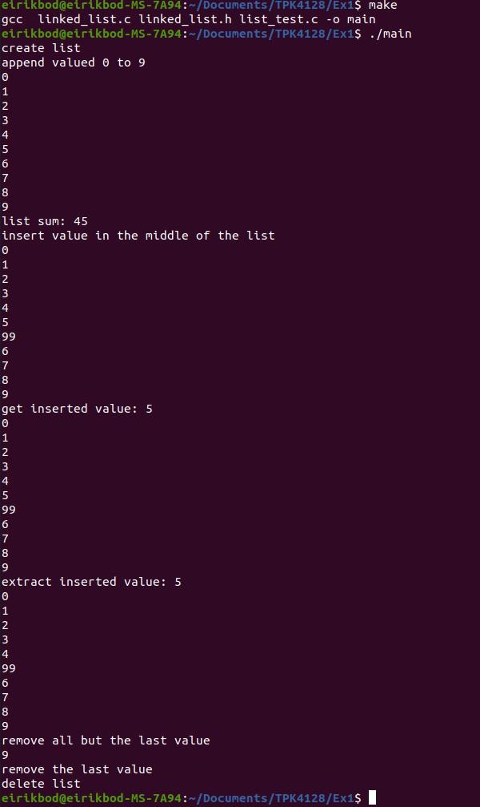
Running with Valgrind to check for memory leaks:
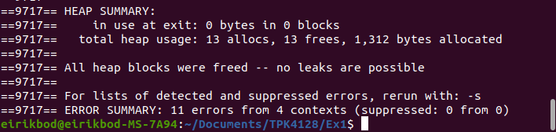
- No memory leaks
2. Error checking

I had no difference in running the program with/without error checks. Possible that I did it wrong. See code in git reposetory

3. Sleep and busy-wait

Execution time is the time the system kernel use to execute a process, if the task sleep or another task is run, the execution time is not incremented. Absolute time is the wall clock time, time the process use from start to end, regardless of how much time the kernel spends on this task. Pausing a process or prioritizing different processes will add to absolute time.

Running the 2 threaded process using the sleep function.

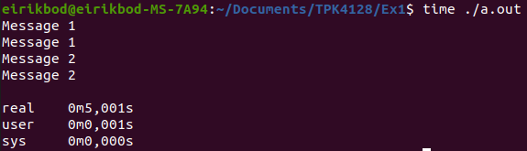
Running the 2 threaded process using a busy-and-wait approach.

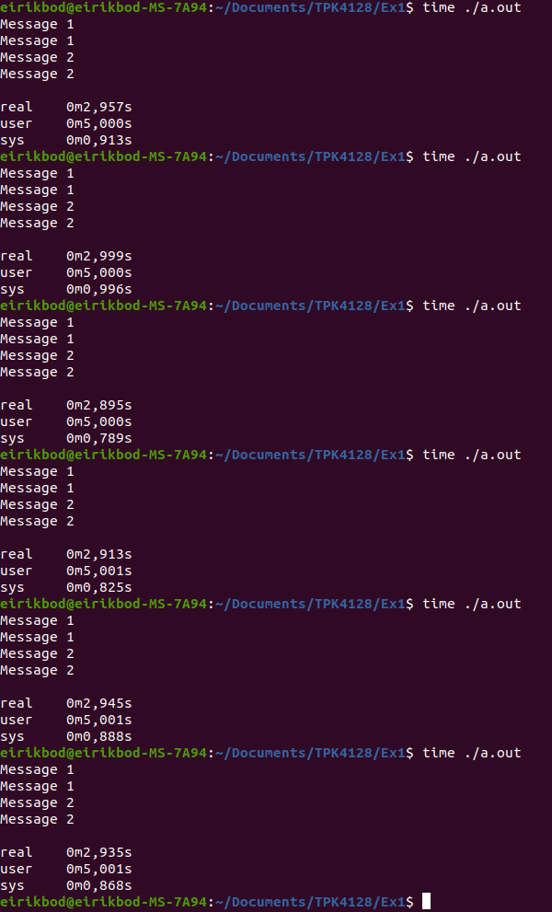

The “user time” is the amount of time on the cpu, outside the kernel. Since the busy-and-wait algorithm execute tasks until enough clock cycles is passed to reach 5s, the user time is around 5s, for every process run. Since the process may run on several cores, the absolute time is actually shorter than the user time. And this is causing the difference in absolute time in the different processes.

